Effects of preconceptional and in utero exposure to Chernobyl fallout on pregnancy outcome and congenital malformations in Belarus
G.Lazjuk*, I.Zatsepin* , B.Gagnière** , P.Verger***, E.Robert**** and R.Khmel*
* Belarus Institute for Hereditary Diseases (Orlovskaja str. 66/8, 220053, Minsk, Belarus)
** Institut de Radioprotection et de Sûreté Nucléaire , France
*** Observatoire régional de la santé РАСА, France
**** Institut Européen des Génomutations, France

Abstract: The prevalence of congenital malformations (CM) was analyzed in Belarus within the framework of 3.5.1 subproject of French-German initiative on the assessment of the Chernobyl accident aftermath. The data of population registry of Belarus Institute for Hereditary Diseases were used in the study. No consequences of long residence in the contaminated areas due to the accident have been registered. The increased prevalence of the surveyed CM during the first years after the accident, recorded in the areas with high radionuclide contamination, if not being the result of screening effect, can be ascribed to the set of negative factors appeared in the affected territories. Anomalies with high share of de novo mutation (polydactyly, reduction limb defects and multiple CM) and also anencephaly were found the main contributors to the recorded increase. The most probable cause of the Down’s syndrome prevalence pick in January of 1987, found the highest for over 20-year study period, was the short-term intensive radiation exposure of the considerable part of Belarus population at the time of the radioactive clouds passage. Evident deficiency of head circumference in newborns exposed in utero as compared with the control could be a sign of negative effect of radiation exposure of Belarus population due to Chernobyl accident on the normal development of fetal cranium. The decreased head sizes, however, could result from interethnic differences between the residents of north-western and south-eastern parts of Belarus.

Introduction

Nearly twenty years have passed after the Chernobyl accident (April 26th 1986), but still there are much uncertainties concerning the health consequences in exposed population. The possibility that preconceptional or in utero exposure to ionizing radiation may affect pregnancy outcome remains a matter of public concern and scientific debate [1]. Belarus National Registry (BNR) of CM, a population-based monitoring system functioning in Belarus Institute for Hereditary Diseases since 1979, is the only CM register existed before the accident in 3 most exposed to the Chernobyl fallout countries (Belarus, Ukraine and Russia). Thus, BNR provides a unique possibility to study the effects of Chernobyl accident on pregnancy outcomes.
The main objectives of the subproject 3.5.1, performed within the framework of French-German initiative on the Chernobyl accident were the following:
- Validation of BNR data reliability;
- The analysis of 9 mandatory registered CM prevalence at birth in respect to the Chernobyl accident;
- The study of sentinel phenotypes due to imbalanced structural chromosomal aberrations;
- The study of head circumference of in utero exposed newborns.
Some preliminary results could be found elsewhere [2,3]

Results

Results of BNR validation

The study allowed BNR to be asserted as a reliable tool for studying possible teratogenic and mutagenic effects of Chernobyl accident, since the main principals of the registry functioning and the prevalence rates for the studied CM group were found consistent with those reported by European registries within the International Clearinghouse for Birth Defects Monitoring System [2]. The Belarus Registry shows high level of recording completeness (above 85% at all times), the long (over 20 years) functioning period, wide geographical coverage (the whole Republic) and monitoring of easily diagnosed CM with no differences in the recording procedure and minor differences in the registration quality between the regions.

Analysis of CM prevalence trends in view of the Chernobyl accident

The prevalence of 9 easily diagnosed CM has been studied for the period of 1983 to 1999 in 4 oblasts (large administrative areas of the Republic with the mean population of nearly 2 million people and about 20 thousand annual births) selected for their different levels of radionuclide contamination. The following CM were analyzed: 1) anencephaly, 2) spina bifida, 3) cleft lip and/or palate, 4) polydactyly, 5) limb reduction defects, 6) esophageal atresia/stenosis, 7) anal atresia/stenosis, 8) multiple CM group and 9) Down's syndrome. Gomel and Mogilev oblasts were considered as high-contamination areas and Vitebsk and Minsk oblasts were chosen for the control. The results were compared with the previously obtained data in smaller groups of rural areas with similar social and economic situation, but highly contrasting in the radionuclide contamination: 17 districts (small administrative areas with the mean population of nearly 50 thousand people and about 500 annual births) assigned to thorough radiological control area (TRCA) versus 30 districts considered contamination-free (Fig.1) [4].
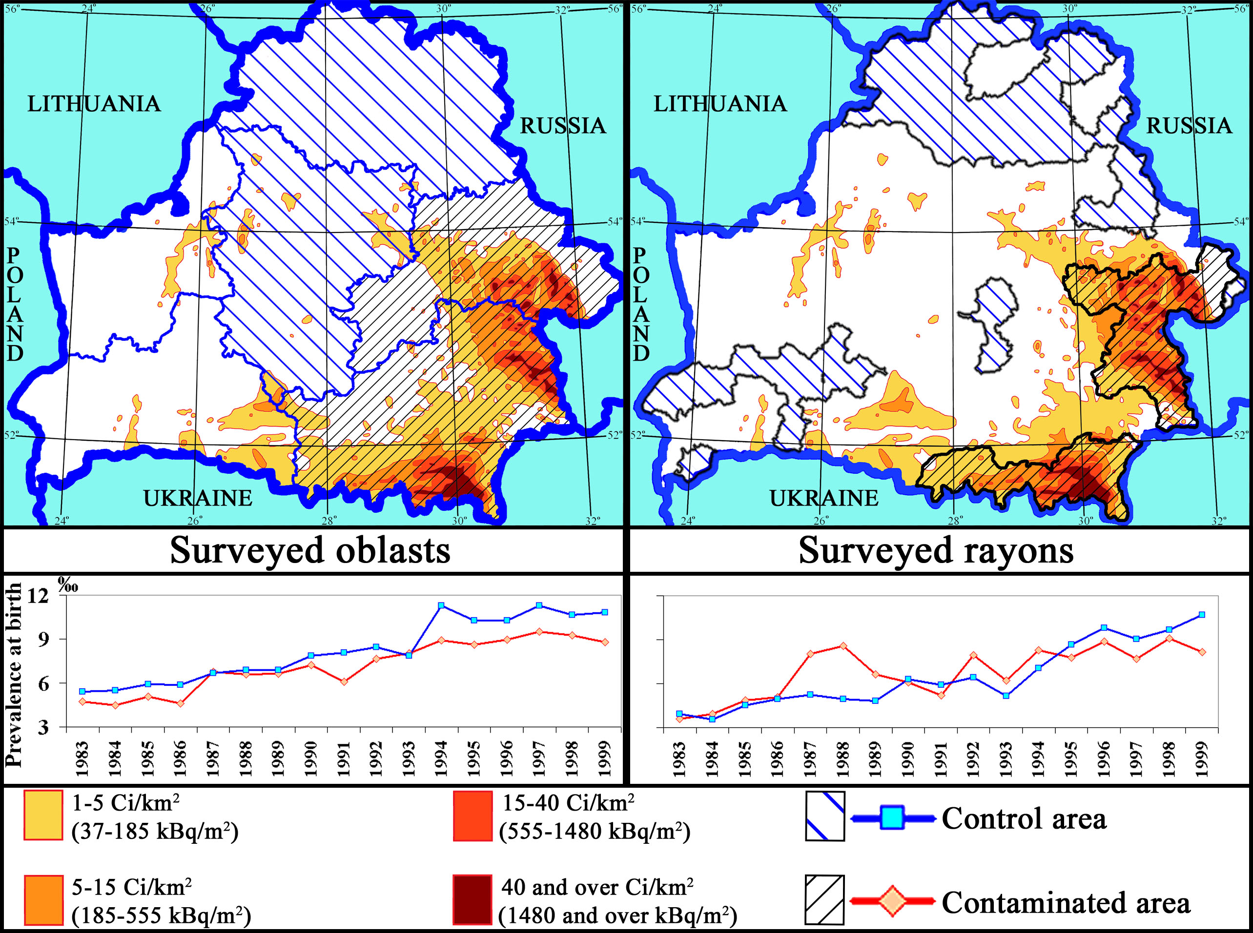
Fig.1. Time trends for prevalence at birth of 9 surveyed CM combined, traced in the areas varied in radionuclide contamination level
For the period of 1983 to 1999, about 12 thousand newborns and abortuses with any of 9 selected CM were registered in 4 surveyed oblasts (111 rayons) and over 2 thousands being recorded in 17 TRCA districts and 30 control ones. Both investigations revealed a positive time trend over the entire period with similar magnitude in low- and high-contamination areas (Fig.1). In contrast to the study on the district level, CM prevalence was found slightly lower in the contaminated oblasts (Gomel and Mogilev) than in the control (Minsk and Vitebsk), including the pre-accident period. The finding evidenced certain inadequacy of the selected groups probably due to initial interregional discrepancies.
Similar increase of relative risk during the first post-Chernobyl period as compared with the pre-accident years was found in both investigations; however significant excess of CM prevalence in the first years after the accident was recorded only in TRCA districts (Fig.2). Among separate nosologic units, anencephaly, polydactyly, limb reduction defects and the group of multiple CM were the main contributors to the temporally increased CM prevalence.

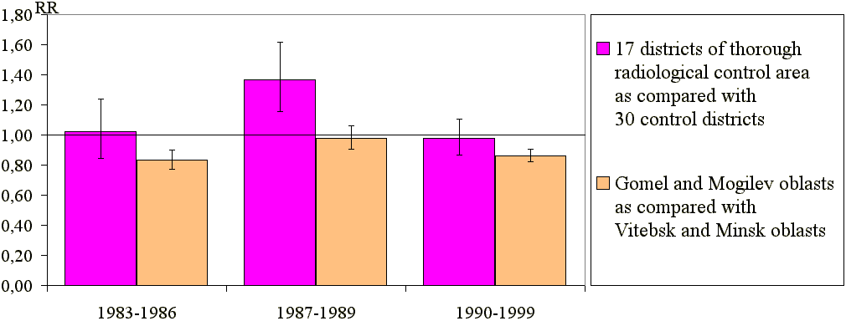
Fig.2. Relative risks and corresponding 95 % confidence intervals for 9 CM combined, registered in newborns and fetuses in different areas of the Republic of Belarus
Certain studies, preformed in Europe, evidence potential association between radiation exposure of the population and increased risk of conceiving children with Down's syndrome (DS) during the period of enhanced radiation exposure [5,6,7]. Analysis of monthly DS prevalence revealed significant pick in January of 1987 (Fig.3), when the observed number of DS cases (O=31) exceeded the expected one (E = 13.9) more than twice (O/E = 2.2) with 95% confidence interval for O/E being 95%CI = [1.5;3.2]. The greatest increase was registered in the most contaminated Gomel oblast (O/E = 8/2.6 = 3.1; 95%CI =[1.4;6.2]), with the population most exposed to Chernobyl fallouts.

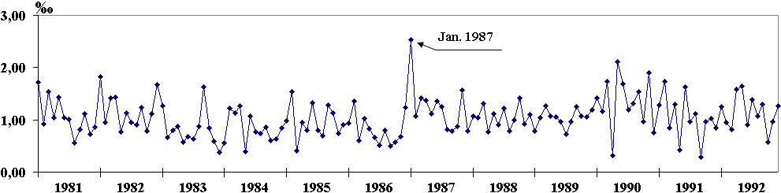
Fig.3. Monthly prevalence at birth of DS in Belarus for the period of 1981 to 1992 (n=1961)
The time of the cluster appearance coincided with the theoretically expected period of DS children births, who were conceived during the first five days after the accident, when a sharp increase of exposure dose rate was observed in the contaminated areas [8]. Our calculations accounted 78 % of such births for January 1987. The spatial distribution of DS children, forming the cluster, well followed the radioactive cloud passage within the first post-accident days (Fig.4) [3].

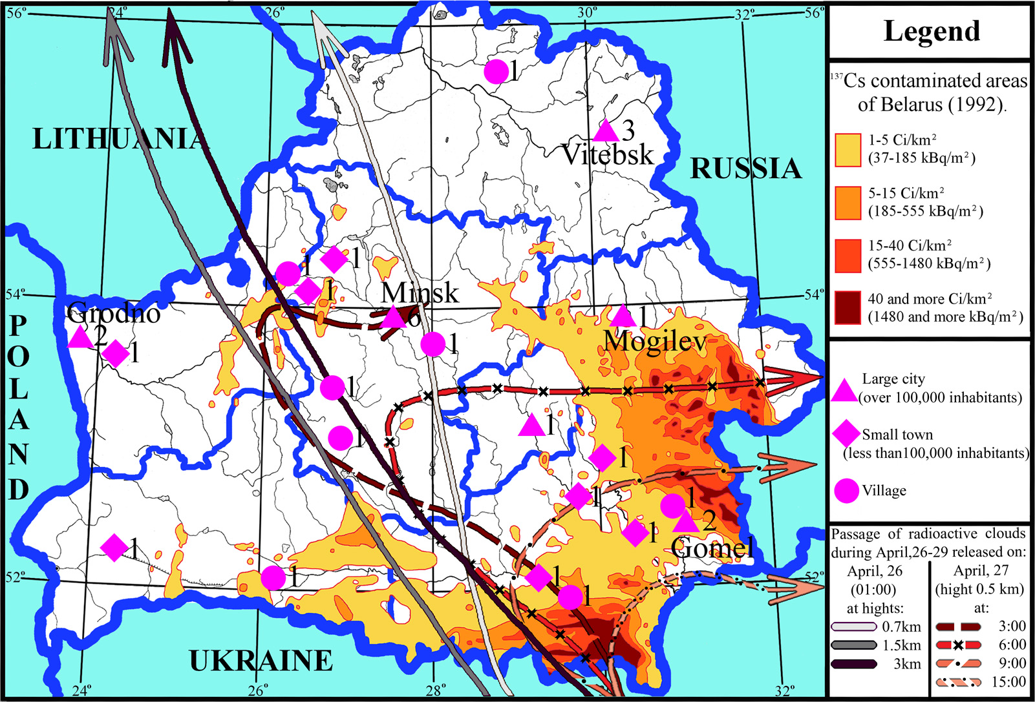
Fig. 4. Spatial distribution of DS children, born in January of 1987, and different factors of radiation pollution in Belarus

The study of sentinel phenotypes due to imbalanced structural chromosomal rearrangements

Two hundred twenty one cases with sentinel phenotypes due to imbalanced structural chromosomal aberrations have been traced to study the ratio of de novo versus inherited mutations in Belarus oblasts, contrasting in contamination levels. The information was obtained from medical records of the families applied for counseling at medical genetic centers of the Republic. According to the results of the logistic regression analysis, performed to reveal differences between defined periods and contamination groups, there is a significant "period effect" when odds ratio was (OR=1.89, p=0.036), however no pronounced contamination effect was observed (OR=1.57, p=0.25). Thus, we observe a general increasing trend in the Republic for the percentage of de novo ISChA cases and no visible association with radioactive contamination could be found in the surveyed oblasts (Fig.5).
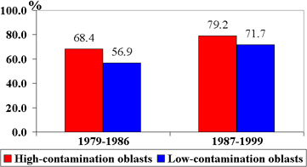
Fig. 5. Ratio of de novo to inherited cases of sentinel phenotypes due to imbalanced structural chromosomal aberrations

Retrospective study of head circumference of in utero exposed newborns in Belarus

Prenatal developmental delay of head growth indicates an increased risk for microcephaly, a known aftermath of the in utero radiation exposure [9]. To follow this, head circumferences of newborns, whose mothers during their pregnancies in 1986 and 1987 were living in the settlements with ¹³⁷Cs soil contamination of at least 15 Ci/km², were studied retrospectively. Newborns from contamination-free settlements of Vitebsk oblast were taken for the control. The information from maternity hospital records served as a source of the collecting data. Multiple births and newborns with disorders that can affect the head size (CM of central nervous system and chromosomal diseases) were excluded from the analysis. About 1 thousand records were selected for exposed and control groups, each.
The study showed significantly smaller mean values of head circumference in newborns by 1.1 cm in the exposed group as compared to the control (p<0.001; t-test for independent samples, Mann-Whitney U and Kolmogorov-Smirnov tests) (Fig.6).
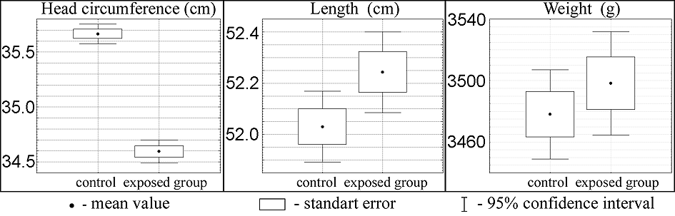
Fig. 6. Mean value (point), standard error (box) and 95% confidence intervals (whiskers) of newborns’ anthropometrical sizes in control and exposed groups.

Moreover, the rate of anomalously small head circumference estimated for the newborn’s gestational age (Fig.7) and their weight (Fig.8) in this group was significantly higher. The revealed differences were not the result of general hypotrophy of fetuses, since the compassion groups were nearly similar in weight and length of newborns. Negative effect of radiation exposure on the growing fetal brain could be one of possible causes; however local peculiarities of population, residing in various areas of Belarus, could not be ruled out completely at the current stage of the study. The obtained results necessitate further investigations, including the analysis of pre-accident period.

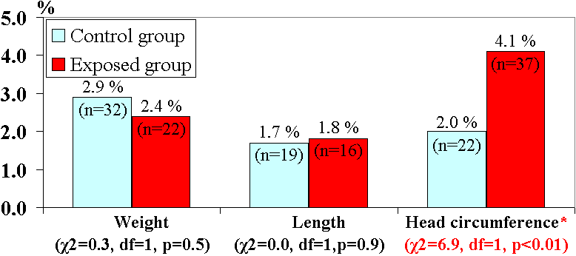
Fig. 7. Percentage of newborns with deficient anthropometrical sizes determined by centile tables of Versmold H. [10] according to gestational age

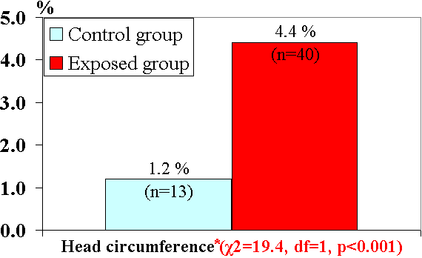
Fig. 8. Percentage of newborns with deficient head circumference determined by centile tables of Lie R.T. et al. [11] according to the weight at birth

Conclusions

Most epidemiological studies performed in Europe failed to show considerable effects of radiation exposure due to the Chernobyl accident on the CM prevalence [9,12,13]; however scarce positive findings regarding CM and chromosome aberrations deserve thorough scientific examination considering high social implication of the problem [1].
The results of the project do not exclude negative effects of the radiation exposure on CM prevalence, at least during the first period after the accident; however several confounding factors, including a screening effect resulted from an enhanced interest to CM because of the accident, might have some impact. However rather high registration completeness of CM in BNR should prevent from considerable contribution of the screening effect and 3-year period of increased prevalence indexes for most CM indicates a non-stochastic nature of the event. Considerable contribution of de novo mutations in the etiology of polydactyly, limb reduction defects and the group of multiple CM [14] with recorded increased prevalence in highly contaminated districts might evidence possible increase of mutagenic pressure on the population. Increased prevalence of anencephaly and decreased head circumference could be a sign of teratogenic effect of the exposed population of Belarus.
Neither of currently known factors altering the recorded DS prevalence could be the major cause for the observed cluster in January 1987. We can not completely exclude stochastic nature of January 1987 pick of DS cases; however experimental studies on mammals showed that relatively small exposure doses can cause numerical chromosomal aberrations on specific stages of oogenesis, directly preceding ovulation and conception [15,16], which can serve as theoretical backgrounds of the obtained results. Moreover, similar conclusions regarding the impact of maternal radiation exposure shortly before the conception were made in other epidemiological studies [5,6]. It is noteworthy that spontaneous rate of aneuploidy in human is more than an order of magnitude higher than in mice [17] (the most common model of radiation exposure effects), evidencing high predisposition of human gametogenesis to abnormal chromosomal disjunction in meiosis, which is possibly due to higher sensitivity to environmental factors. Thus, extrapolation of the results of experimental studies might lead to underestimation of the exposure risks in human.
The lack of exhaustive dosimetry data is the main reason making final conclusions difficult. However current progressive number of scientific groups reconstructing the effective equivalent doses obtained by Belarus population due to the Chernobyl release, promises further investigations of possible effects of the accident on embryonal anomalies using more reliable methods for comparison group formation.

Reference

- W. Hoffmann, Arch.Environ. Health. 56 (2001).
- G. Lazjuk P.Verger, B.Gagnière, Zh.Kravchuk, I.Zatsepin, E.Robert, Reprod.Toxic. 17 (2003).
- I.Zatsepin, P.Verger, E.Robert-Gnansia, B.Gagnière, R.Khmel, G.Lazjuk, Int.J.Rad.Med. 6, (1-4). (2004).
- G.I.Lazjuk, D.L.Nikolayev, I.V.Novikova, A.D.Polityko, R.D.Khmel, Int.J.Rad.Med. 1, (1) (1999).
- K.Sperling, J.Pelz, R.D.Wegner, A.Dorries, A.Gruters, M.Mikkelsen, Brit.Med.J. 309 (1994).
- J.P.Bound, B.J.Francis, P.W.Harvey, J.Epidemiol.Community Health 49 (1995).
- A.Ericson, B.Källén, Environ. Res. 67 (1994)
- M.Yu.Orlov, V.P.Snykov, Yu.A.Khvalenskij, A.A.Volokitin, AtomicEnergy. 80, 6 (1996).
- D.Bard, P.Verger, Ph.Hubert, Epidemiol.Rev. 19, 2 (1997).
- Versmold H. Richtlinien Neonatologie (Berlin.,1997).
- R.T.Lie, L.M.Irgens, R.Skjaerven et al., Am.J.Epidemiol. 136 (1992).
- UNSCEAR 2001 Report. Annex: Hereditary Effects of Radiation.
- P.Verger, Health.Phys. 73 (1997).
- V.McKusick. Catalogs of Human Genes and Genetic Disorders. (Baltimore: Johns Hopkins University Press, 1998).
- H.J.Evans, M.F.Lyon, A.Czeizel, Mutat.Res. 175 (1986).
- C.Tease, Mutat.Res. 95 (1982).
- K.Sperling in Mutations in man, edited by G.Obe, (Springer, Berlin, 1984).

